**SANGTHEETHA CHANDRASEKARAN (B031610424)**

**Lab Activity – Self Exploration**

Create an account from GitHub and please maintain your profile well for the sake of your future.

Find and take a look on the available public REST API such as <https://github.com/toddmotto/public-apis>

Choose one of the public API and understand the documentation:

**Bhagavad Gita API**

* The Bhagavad Gita Application Programming Interface (API) enables a web or portable engineer to utilize the Bhagavad Gita message in their web or versatile application(s).
* It is a RESTful API.
* All the data is sent and received as JSON.
* ALL API access is over HTTPS.
* HTTP solicitations to the BHAGAVAD GITA API are secured with OAUTH2 validation.

1. List out the parameters that the API able to receive.

* **GET:** Chapters >> Get all 18 chapters of the Bhagavad Gita.

Chapter_number >> Get a specific chapter from the Bhagavad Gita.

* **POST:** Send client credentials and get an access token (oauth).

1. List out are the responses that the API return (the JSON values).

* **Client ID** - Obtained from Account Dashboard after registering an app.
* **Client Secret** - Obtained from Account Dashboard after registering an app.
* **Grant Type** - Use client credentials.
* **Scope** - Use verse if you just want to access the verses, chapter if you just want to access the chapters and verse chapter if you want access to both.

1. Create an application that able to interact with the API that you have chosen. The application should be able to pass parameters according to user input (no fixed or hard-coded parameters).

Respiratory URL: <https://github.com/SangtheethaChandrasekaran/CountryStatus.git>

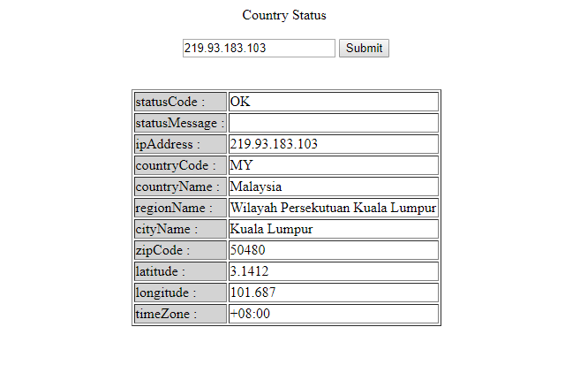

1. Interface

Here I have done simple source code which can interact with JSON. Above figure shows Get and Post request and Read JSON response. Above form is to get country status such as status code, country code, country name and many more. This can be identifying using IP Address. Here I have used ipinfocb.com. We can send GET Request and with IP address, it will give JSON response with details of IP address.

1. Source Code

